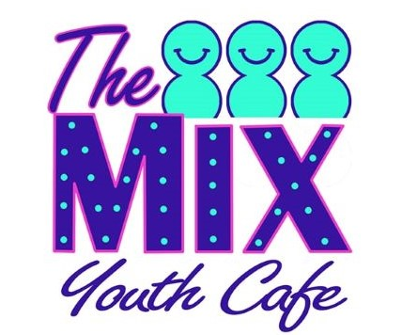
CONFIDENTIAL Information Form to be completed by Parent/Guardian. 2022-3

In case of emergency, it is vital that we hold accurate, current information on medical/non-medical conditions, medications, disabilities, allergies, GP address, etc. We also need a range of up-to-date contact telephone/mobile numbers so that we can respond efficiently in the event of a crisis.

Name of Young Person:______________________________________________________________________Age______

Young Person’s Home Address: _________________________________________________Postcode_______________

HEALTH INFORMATION: The name, address and phone number of my child’s doctor is:-
Doctor _________________________________________________ Doctor’s Address______________________________

___________________________________________________Doctor’s Phone Number _____________________________

Please use the back of this form to provide fullest details of any medical or non-medical issues, medications, allergies, disabilities etc and also advise us of anything else we should be aware of whilst your child is in our care. Please feel free to contact us privately if you prefer.

EMERGENCY CONTACT NUMBERS: In the event of an emergency, it is vital that we have a range of ‘Phone Numbers for you and other family members or friends/neighbours etc. who will respond if you are not contactable.

PLEASE PRINT NAMES AND ‘PHONE NUMBERS CLEARLY

1. Parent/Guardian’s Name: _________________________________ Number: __________________________________

2. Name: ____________________ _______________________________ Number: __________________________________

3. Name: ____________________________________________________Number:__________________________________

I confirm I have read and understood the information provided by The Mix Youth Cafe. I confirm that all details supplied by me are correct and may be shared with leaders directly concerned with my child’s welfare. I agree to my child joining The Mix Youth Café and I understand that Youth Workers cannot prevent a young person leaving the Club premises at any time.

PARENTS/GUARDIANS, Please tick the box if you do not wish The Mix Youth Cafe staff to use photo/video clips of your child for Youth Cafe promotions etc and reports for Funders, as per attached letter

Signed (parent/ guardian): _________________________________________ Date:______________________________

THANK YOU

The information provided on this form will be kept secure and confidential in locked offices. It is only shared with youth leaders involved directly with your child. You can withdraw your child’s membership at any time and request (in writing) that your records are disposed of confidentially.
The Mix Youth Cafe privacy notice is available on our website www.themixcrosby.com or you can request a copy of this from staff.

